Recording Form for Safeguarding Concerns
Abbeydale team members, clinical coaches, employers, colleagues, visitors are required to complete this form and pass it to either Samantha Morgan or Kirsty Gwynne if they have a safeguarding concern about a apprentice at Abbeydale.
Information Required | Enter Information Here
Full name of apprentice
Date of birth
Your name and position
Nature of concern/disclosure
Please include where you were when the apprentice made a disclosure, what you saw, who else was there, what did the apprentice say or do and what you said.
[Ensure that if there is an injury this is recorded (size and shape) and a body map is completed]
[Make it clear if you have a raised a concern about a similar issue previously]
Time & date of incident:
Name and position of the person you passing this information to?
Your Signature
Time and date form completed
Time form received by DSL
Action Taken by DSL
Referral made? [full details, date and time]
Parents Informed [yes/no, date and time]
Feedback given to person who recorded disclosure
[yes/no, date and time]
Further Action Agreed
Full Name of DSL
Signature of DSL
Date of Signature

Body Map
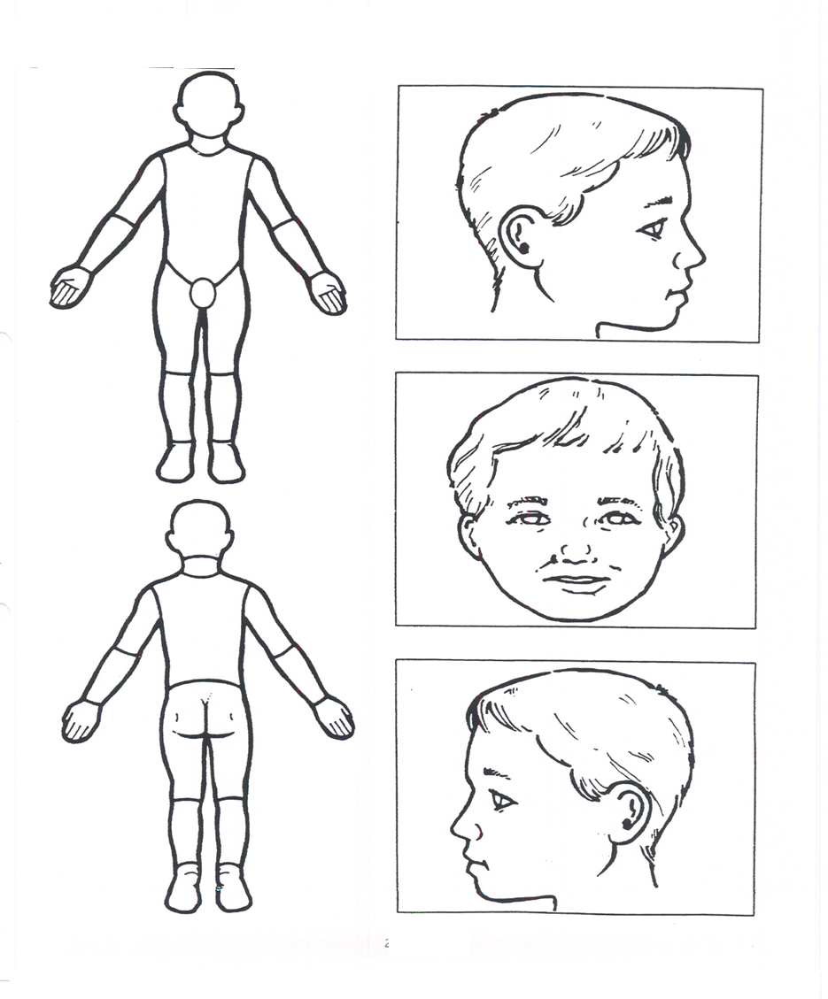
Indicate clearly where the injury was seen and attach this to the referral form

